**Program 1: Landscaping Calculator**

1. import java.util.Scanner;  
   public class Main {  
    public static void main(String[] args) {  
    // variables  
    String address;  
    int length;  
    int width;  
    String typeOfGrass;  
    int numberOfTrees;  
    //constants  
    final int BASE_LABOR_CHARGE = 1000;  
    final double FESCUE_COST_PER_SQUARE_FOOT = 0.05;  
    final double BENTGRASS_COST_PER_SQAURE_FOOT = 0.02;  
    final double CAMPUS_COST_PER_SQUARE_FOOT = 0.01;  
    final int TREE_CHARGE = 100;  
    // input  
    Scanner input = new Scanner(System.*in*);  
    System.*out*.print("Enter the address: ");  
    address = input.nextLine();  
    System.*out*.print("Enter the length: ");  
    length = input.nextInt();  
    System.*out*.print("Enter the width");  
    width = input.nextInt();  
    System.*out*.print("Enter the type of grass (fescue, bentgrass, or campus): ");  
    typeOfGrass = input.next();  
    System.*out*.print("Enter the number of trees: ");  
    numberOfTrees = input.nextInt();  
    // processing  
    double totalCost = BASE_LABOR_CHARGE;  
    int surfaceArea = length * width;  
    if (surfaceArea > 5000) {  
    totalCost = totalCost + 500;  
    }  
    if (typeOfGrass.equals("fescue")) {  
    totalCost = totalCost + (surfaceArea * FESCUE_COST_PER_SQUARE_FOOT);  
    } else if (typeOfGrass.equals("bentgrass")) {  
    totalCost = totalCost + (surfaceArea * BENTGRASS_COST_PER_SQAURE_FOOT);  
    }  
    else if (typeOfGrass.equals("campus")) {  
    totalCost =totalCost + (surfaceArea * CAMPUS_COST_PER_SQUARE_FOOT);  
    }  
    totalCost = totalCost + (numberOfTrees * TREE_CHARGE);  
    // output  
    System.*out*.println("The total cost for landscaping" + address + "is $" + totalCost);  
     
     
    }  
   }

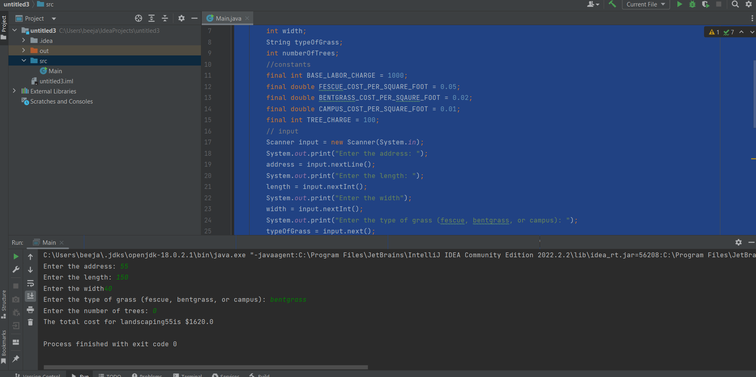

**Program 2. Auto Insurance**

import java.util.Scanner;  
public class Main {  
 public static void main(String[] args) {  
 String gender;  
 int age;  
 double carPrice, insurance = 0, factor=0;  
 Scanner scan = new Scanner(System.*in*);  
  
 System.*out*.println("Are you 'Male' or 'Female': ");  
 gender = scan.next();  
  
 System.*out*.println("Gender" + gender);  
 System.*out*.println("Enter your age:");  
 age = scan.nextInt();  
 System.*out*.println("Enter the purchase price of the Vehicle:");  
 carPrice = scan.nextDouble();  
  
 boolean isMale = gender.startsWith("Male");  
 boolean isFemale = gender.startsWith("Female");  
  
 if (age >= 15 && age < 25) {  
 factor = isMale ? 0.25 : 0.20;  
 } else if(age >= 25 && age < 40) {  
 factor = isMale ? 0.17 : 0.15;  
 } else if(age >= 40 && age < 70) {  
 factor = isMale ? 0.10 : 0.10;  
  
 }  
 insurance = (factor * carPrice)/12;  
 System.*out*.println("Your Monthly insurance will be "+insurance);  
 }  
}

